Review
活 動 回 顧

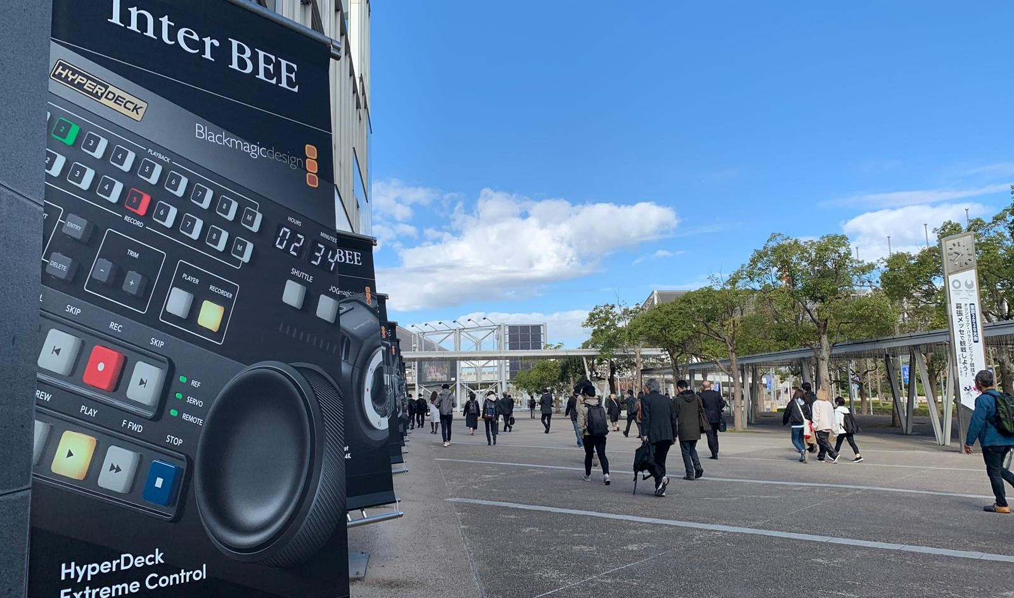

INTER BEE 2019 BROADMEDIA & ENTERTAINMENT

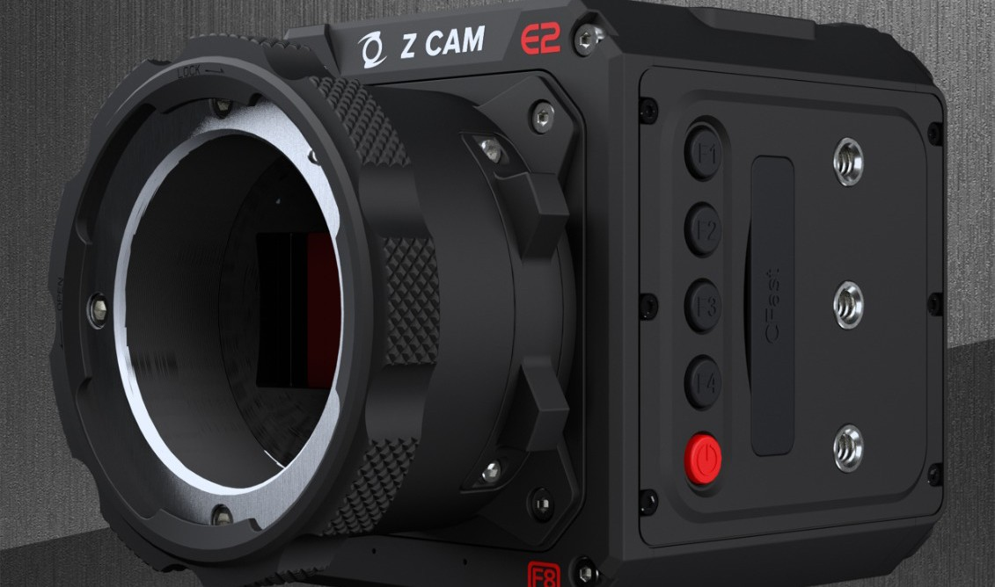

ZCAM FLAGSHIP SERIES
PRESENTATION

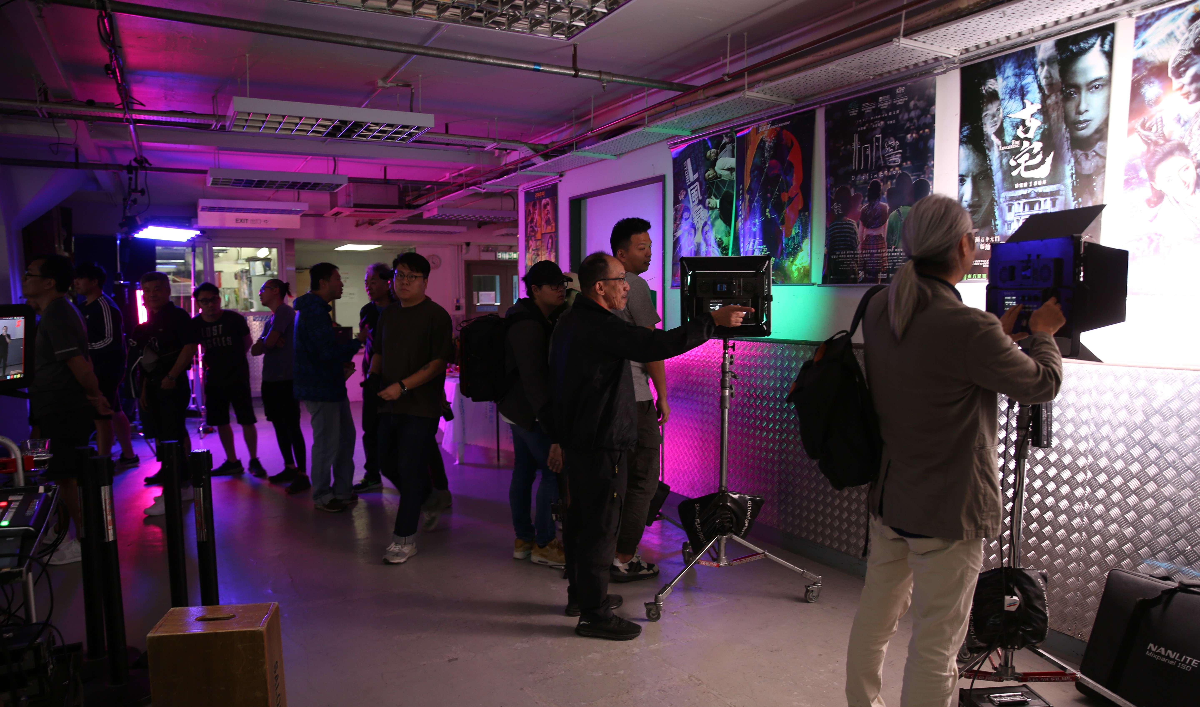

NANLITE TOUCH & PLAY EVENT

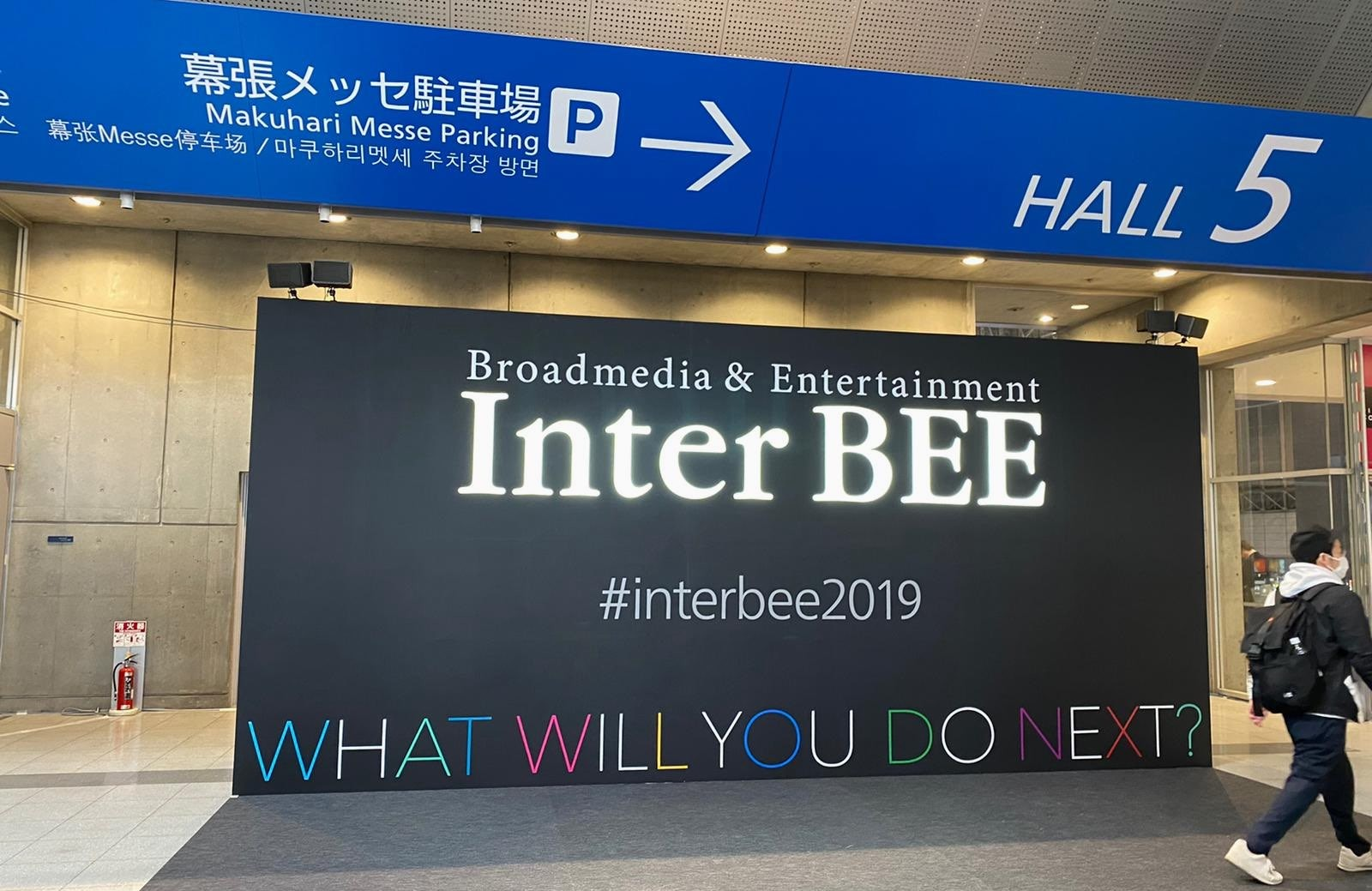NEWSLETTER

Inter BEE 2019
13- 15 Nov Mihama-ku, Chiba City, Japan

Our team had participated in Inter BEE 2019, Japan. Many Japanese are interested in our sole agent products, Nanlite - Forza series, PavoTube and newly launched ZCAM flagship series. Our Managing Director, Mr. Andrew Wang was interviewed by official journal and introduced our company and products to Japan’s market.

11⽉13-15⽇ ⽇本千葉県千葉市美濱區
沙龍⾸次參加⽇本⼀年⼀度的國際影視器材博 覽 Inter BEE 2019，我們今年將全新推出的 ZCAM旗艦系列、南光Nanlite - Forza 系列及 PavoTube產品帶到⽇本展出︔很多⽇本⼈也對我們代理的產品及製作相當感興趣，我們的總經理汪⼈⽴先⽣更接受⼤會專訪，⼤談公司歷史及代理品牌。我們期待下年帶更多新產品及技術
到 Inter BEE 2020!

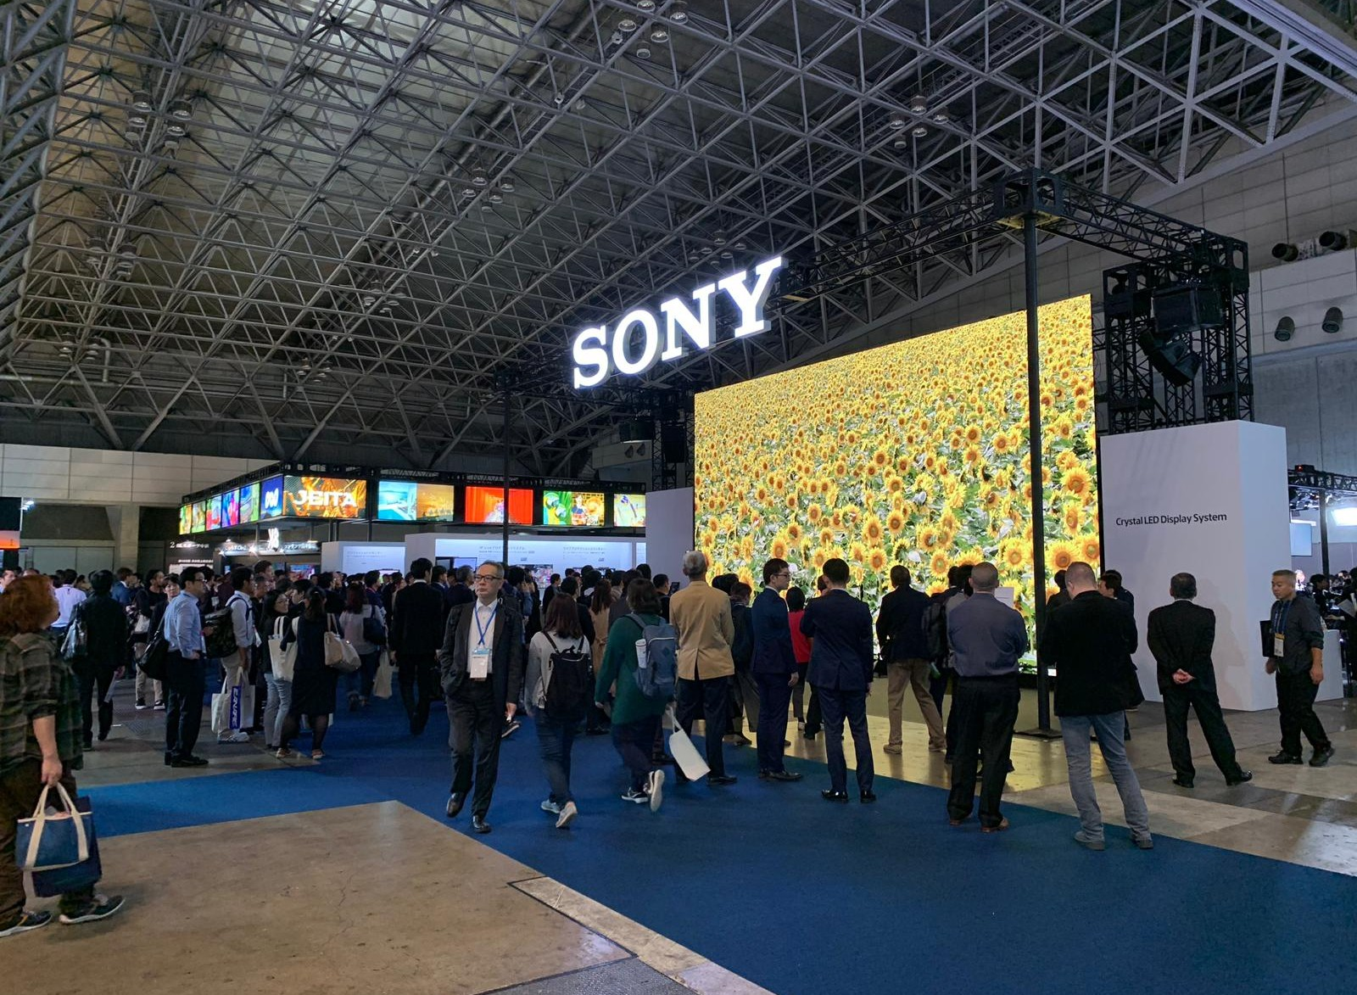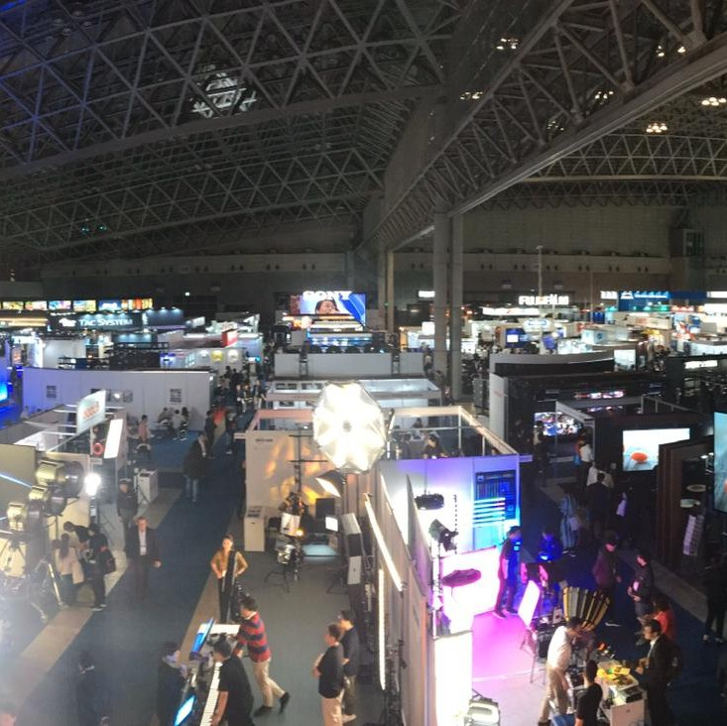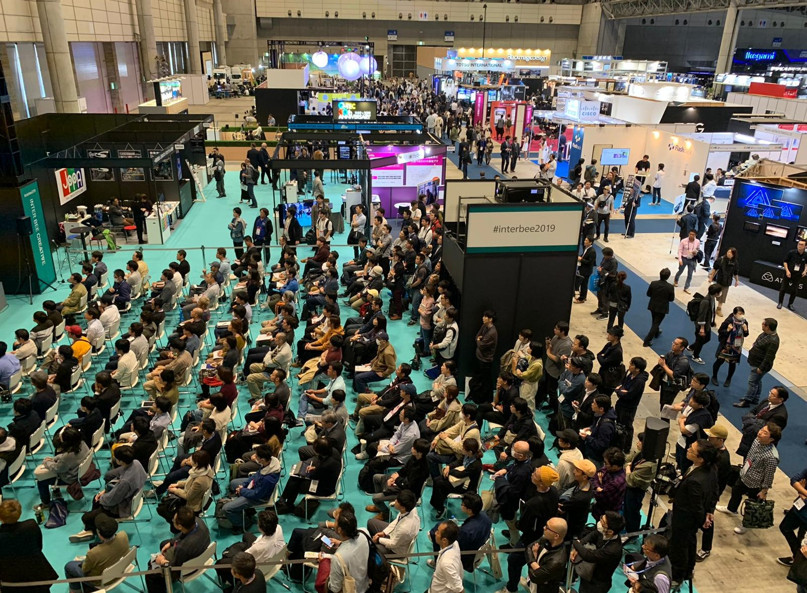

關於
Inter BEE 2019

Inter BEE是⼀一個年年度國際影視及科技展覽，它匯聚了了⽇日本及⾃自世界各地的業界精 英，是⽇日本最⼤大型的影視娛樂樂樂樂貿易易展覽。

About Inter BEE 2019
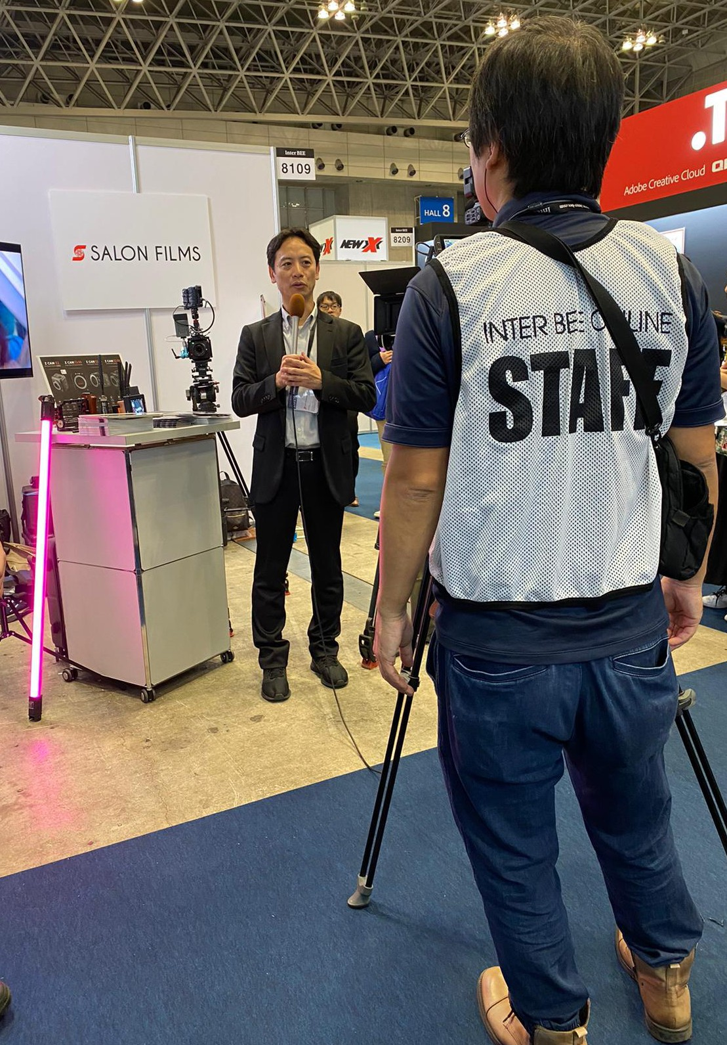
Inter BEE is an international exhibition that brings the latest innovations relating to the content business from Japan and overseas together under one roof as the greatest professional exhibition for audio, video and communications in Japan as backed up by our history and results.

(Left) Our Managing Director, Mr. Andrew Wang, was interviewed by
official journal. 我們的總經理汪⼈
⽴先⽣更接受⼤會專訪。
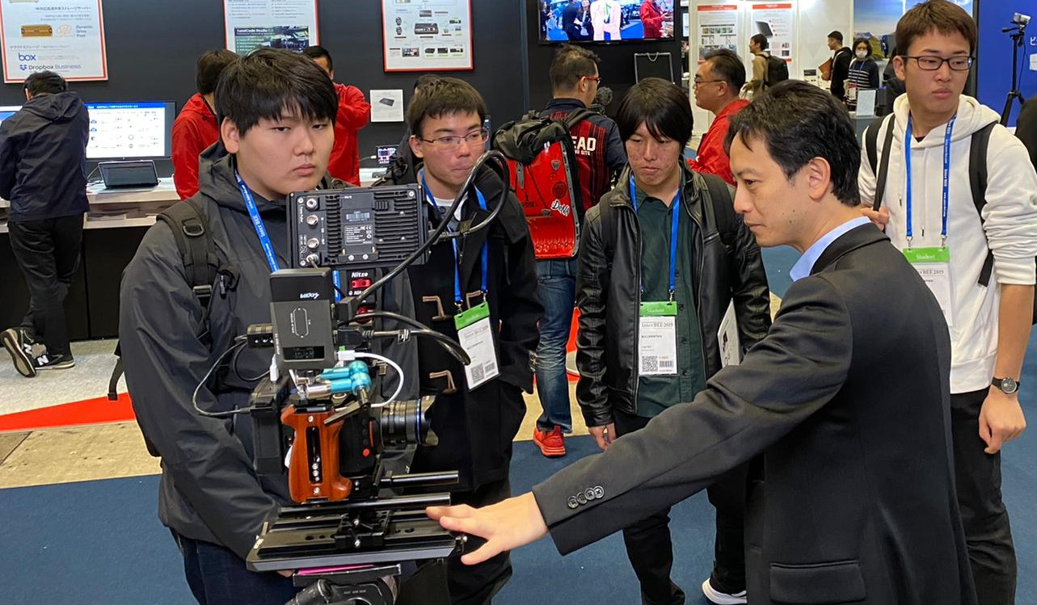
Many Japanese have interested in our sole agent products.
當地⼈對沙龍代理產品相當感興趣。
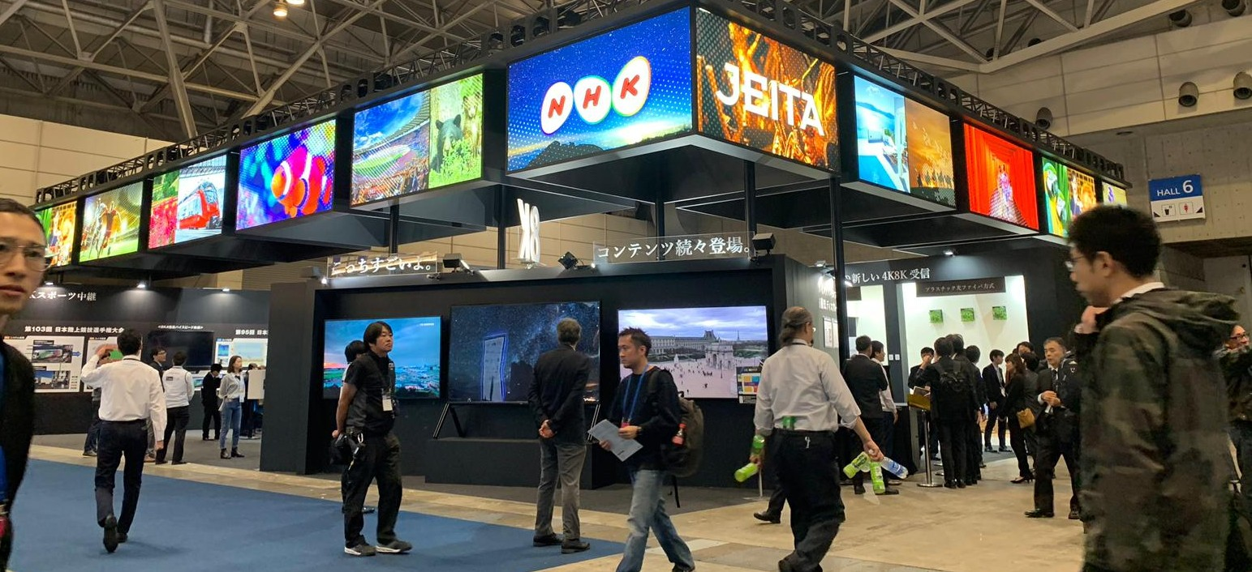
One of the exhibition areas in the Inter Bee.
會場內其中⼀個展區。

ZCAM Flagship Series Product Launch
E2旗艦系列發佈會
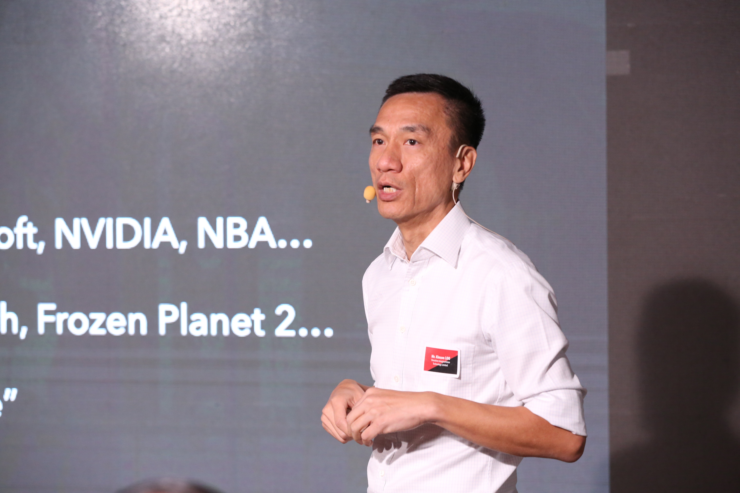
We and Z CAM jointly held the "Z CAM E2 flagship product launch" in Hong Kong on 7th November. Mr. Kinson Loo, the CEO of Z CAM, expounded the Z Cam E2 Flagship series - S6, F6 and F8. All guests were able to experience these new cameras at the launch. In the meantime, colour grading workshop was held for guests who are interested in editing. Thank you for the full support given by the specialist from the industry actively
participate in the event and hope to see all of you in the

next event.

我們與 Z CAM 於11⽉7⽇攜⼿舉辦港澳區的「Z CAM E2旗艦系列產品佈發佈會」已完滿結束，當⽇ Z CAM ⾸席執⾏官盧建⽣先⽣即席介紹了 E2 旗艦系列三部新推出的電影攝影機 - S6、F6 及F8。我們亦提供了這三部攝影機讓來賓即場試⽤，期間更舉辦了調⾊⼯作坊。盛況空
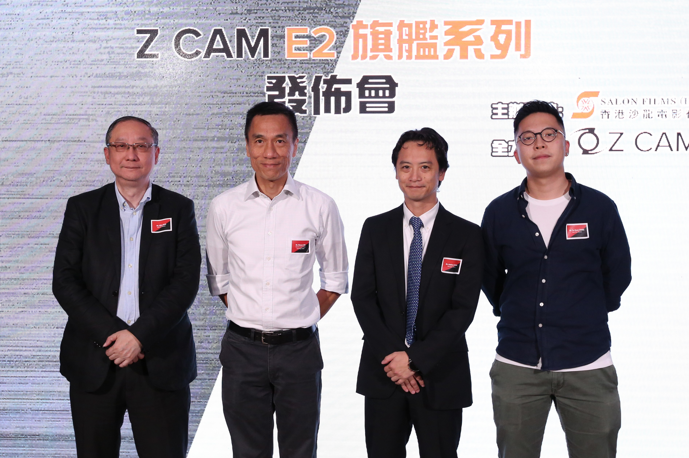
(From Left) Mr. Allen Wan, our Finance & Administration Manager, Mr. Kinson Loo, the CEO of ZCAM, Mr. Andrew Wang, our Managing Director, and Mr. Chong Tsz Kuen, our Marketing and Operation Manager
(左起) ⾹港沙龍電影財務及⾏政經理尹德輝先⽣﹑Z CAM ⾸席執⾏官盧建⽣先⽣﹑
⾹港沙龍電影董事總經理汪⼈⽴先⽣，⾹港沙龍電影市場營銷及營運經理莊⼦權先
⽣ 。
Mr. Kinson Loo, the CEO of ZCAM, was introducing the three new films of the E2 flagship series. Cameras - S6, F6 and F8.
Z CAM ⾸席執⾏官盧建⽣先⽣即席介紹了 E2 旗艦系列三部新推出的電影攝影機 - S6、F6 及F8。

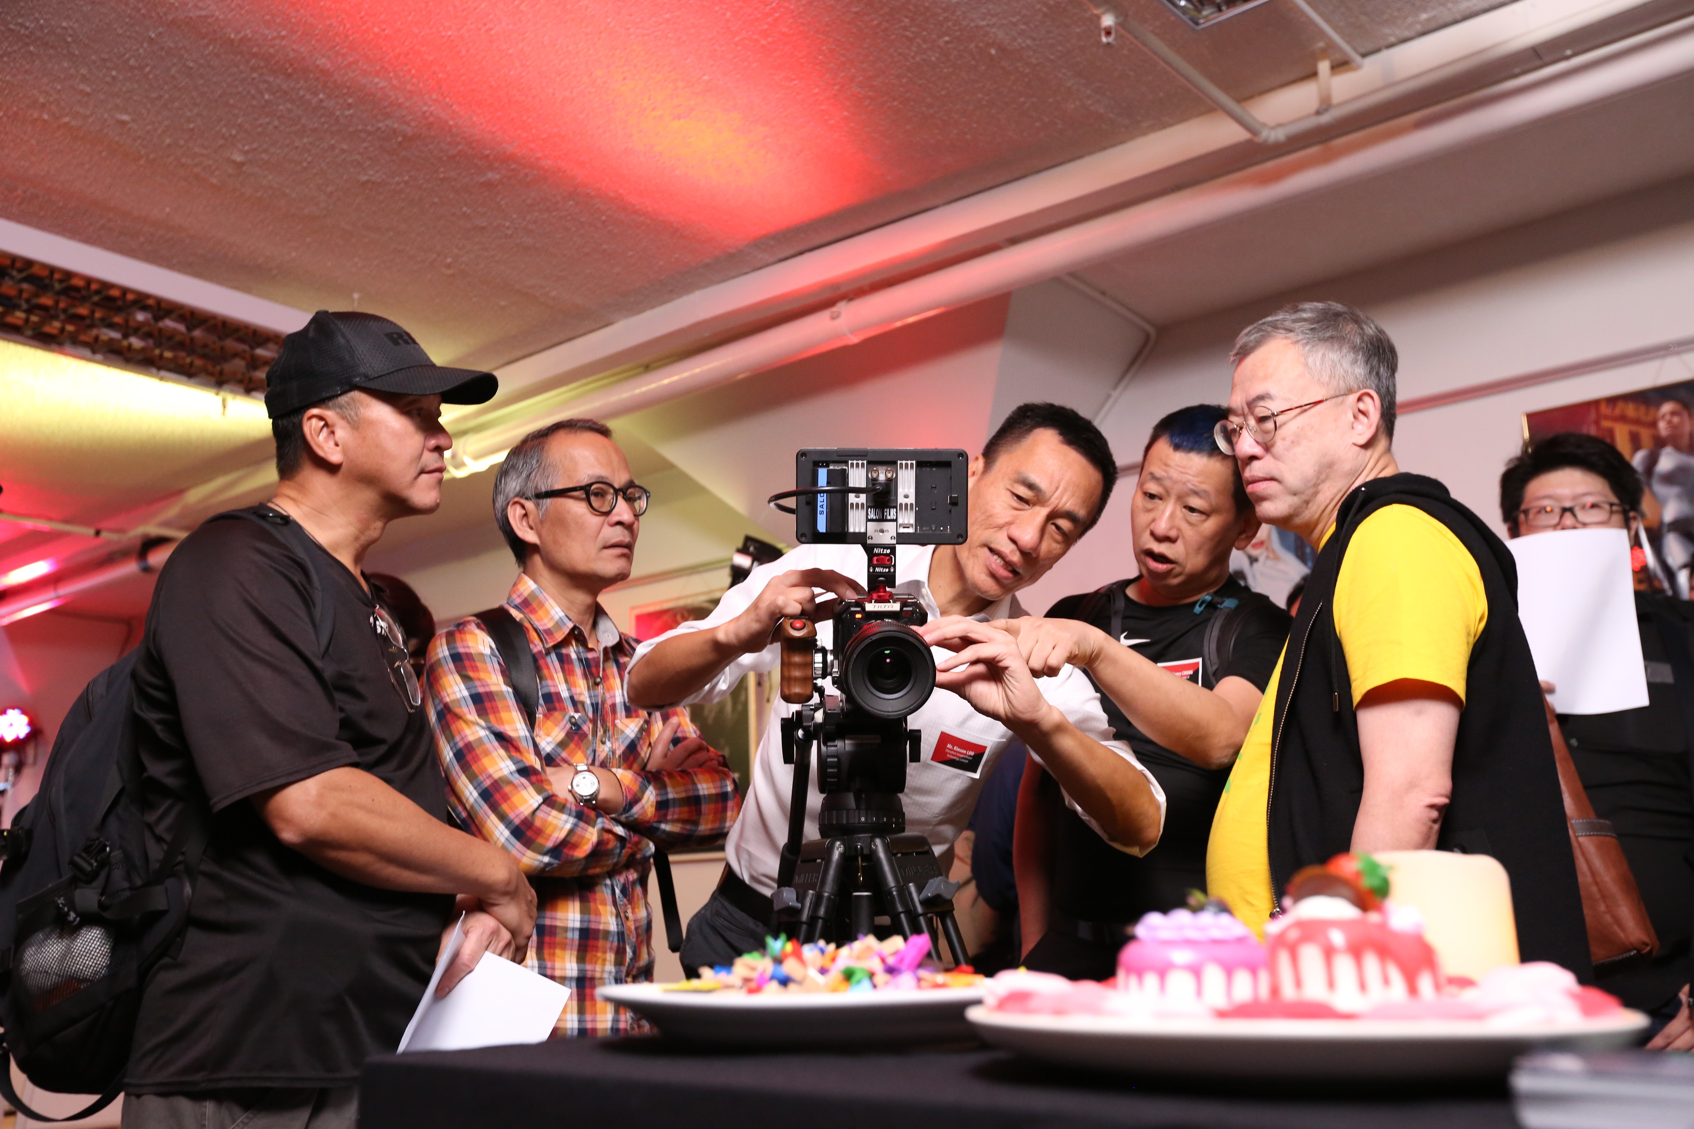

Members of HKSC were testing the new E2-F6 Camera.
⾹港專業電影攝影師學會會員試⽤其中 E2-F6 攝錄機。

Z CAM E2 旗艦系列
Z CAM 堪稱是全世界體積最⼩的電影級攝影機。E2 系列輕巧實惠，已被廣泛應⽤於電影拍攝、紀錄⽚製作、體育及⼤型綜藝節⽬
等。⽽ Z CAM E2 旗艦系列性能更全⾯，相信將會更受業界及家庭⽤⼾推崇。相對之前

的型號，E2 旗艦系列全為 6K 或以上，同時⽀援拍攝所需的 EF 及 PL 鏡頭接環。E2-F6 及 E2-F8 除了
擁有全畫幅圖像感測器，更加能處理直播 8K 電影攝影機。⽽ E2-S6 更是超35mm 畫幅圖像感測器的電影攝影機。根據業內趨勢，採⽤全畫幅圖像感測器已成為拍攝電影的⼤勢所趨。Z CAM E2 旗艦系列的網上預購已的告⼀段落，如欲訂購可聯絡⾹港沙龍電影有限公司。(電話：6191-4230 莊先⽣3 、6275- 5006 陳先⽣、澳⾨熱線：+853 2871-6333︔電郵 ：sales@salonmedia.com)

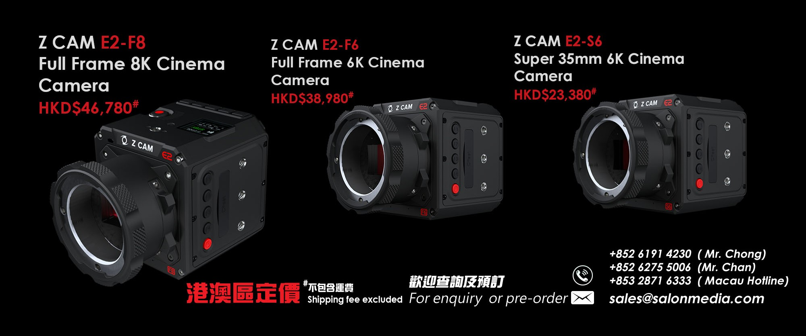

NANLITE TOUCH & PLAY
“NANLITE TOUNCH & PLAY” event were successfully
completed on 31rd Oct. We invited Mr. Peter Wu, the Technical Director of NANLITE, Guangdong Nanguang Photo & Video Systems Co. Ltd., shared the technical skills and experience of FORZA lighting series. We specially thanks to “Hong Kong Cinematography Lighting Association” and “Film Professionals Training Programme” for kind supporting and participation.

⾹港沙龍電影有限公司與NANLITE廣東南光影視器材有限公司攜⼿舉辦的⾹港區的「NANLITE南光產品Touch & Play活動」已於10⽉31⽇順利完成。當天南光燈光技術指導吳奕光Peter更親⾃解說FORZA 系列及燈光技術運⽤。活動更得到⾹港電影燈光協會會員及⾹港專業電影培訓計劃師⽣⽀持來臨，期間⾹港電影燈光協會會長暨⾹港電影
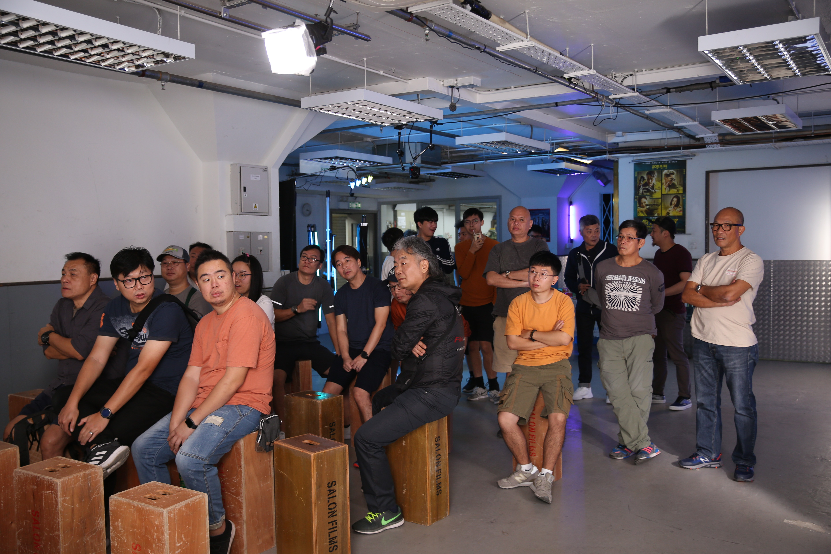
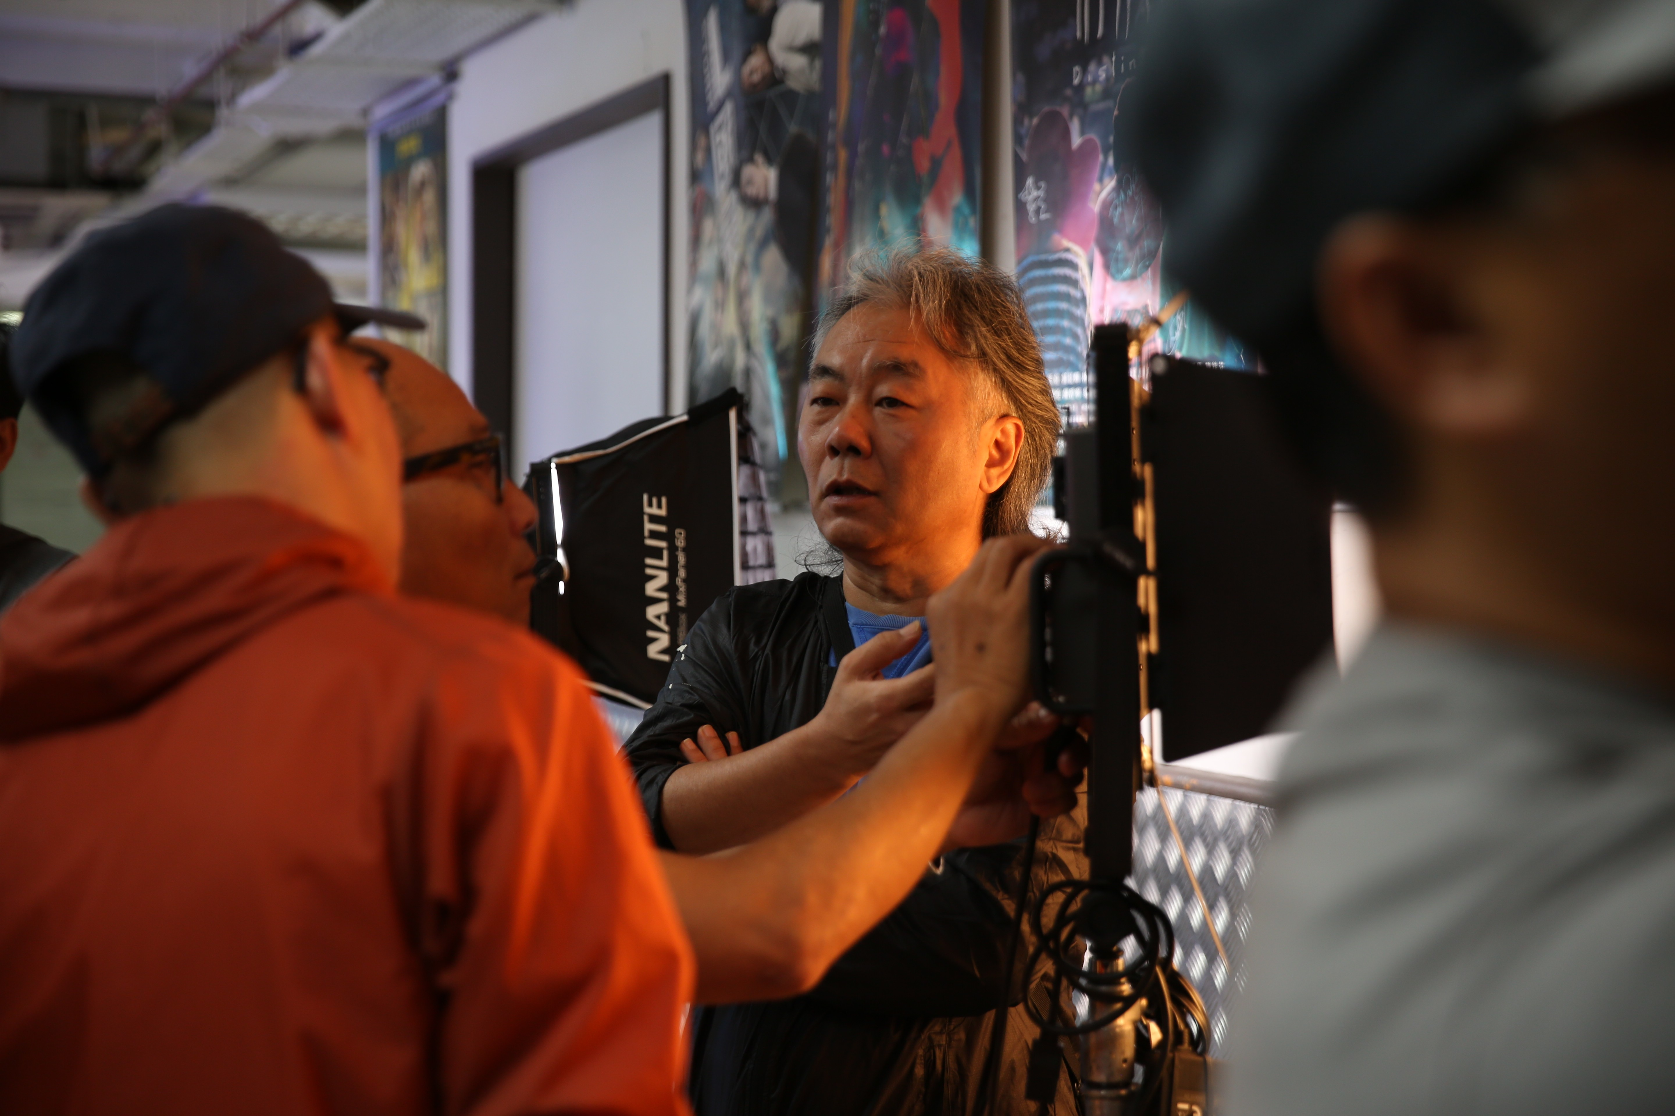
⾦像獎董事局成員- ⽂振榮先⽣及曾於2010年第29屆⾹港電影⾦像獎獲得專業精神獎燈光師- 鄒林先⽣及著名燈光指

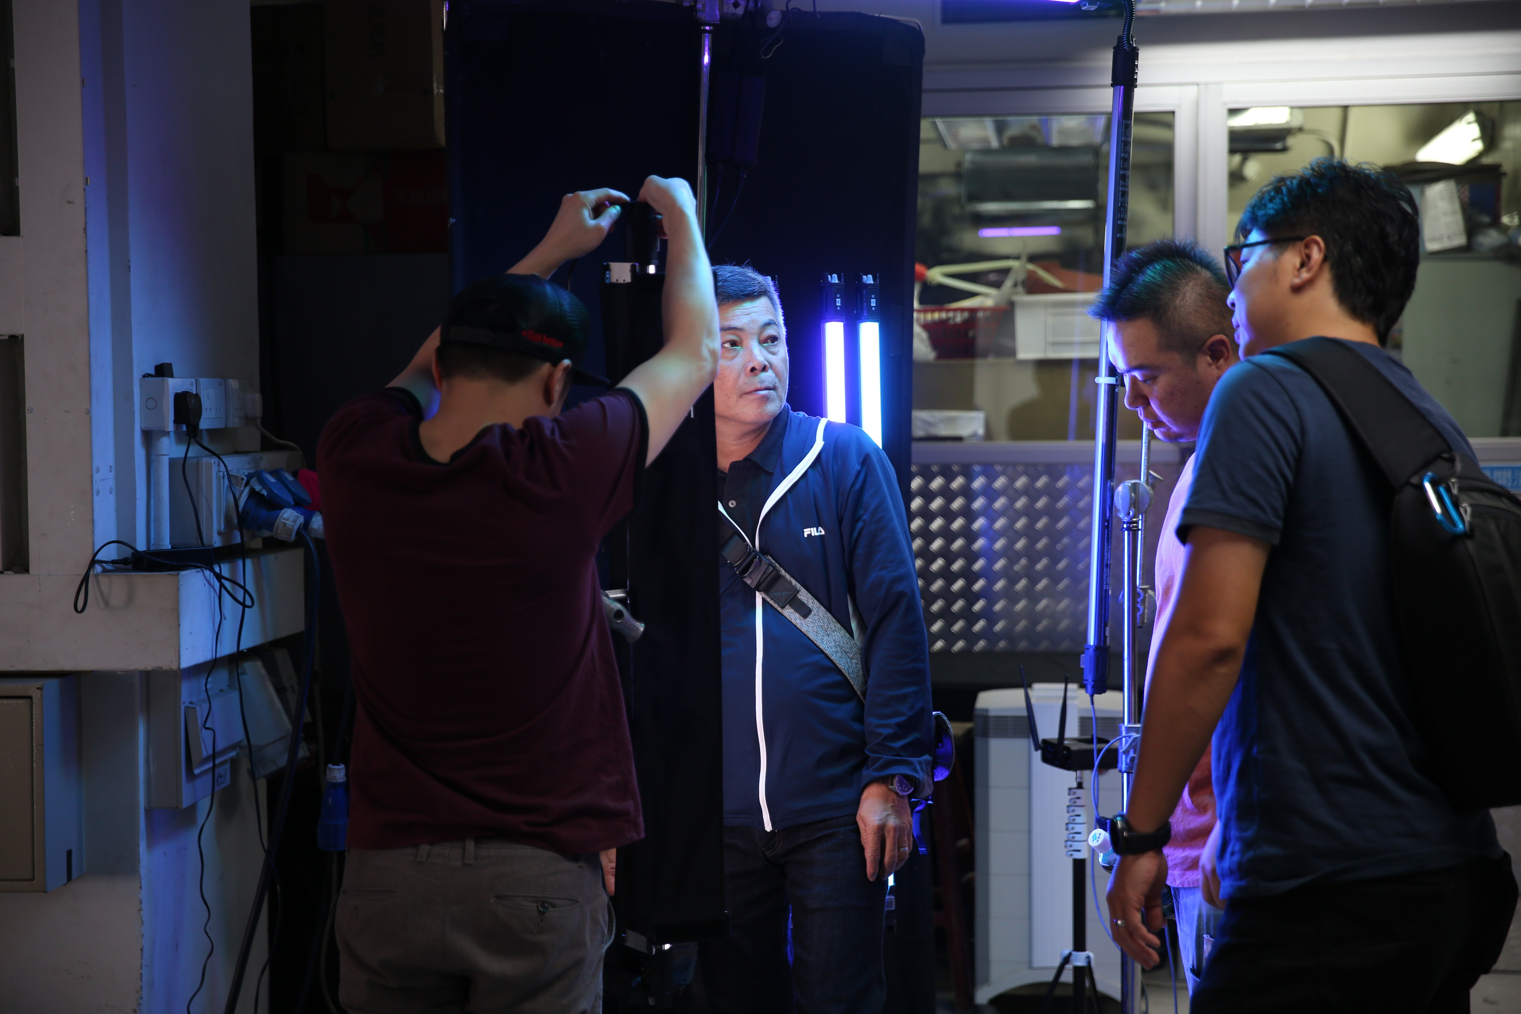

Mr. Man Chun Wing, the Chairman of Hong Kong Cinematography Lighting Association, was testing NANLITE
FORZA series. ⾹港電影燈光協會會長⽂振榮先⽣試⽤南光
FORZA系列燈具。

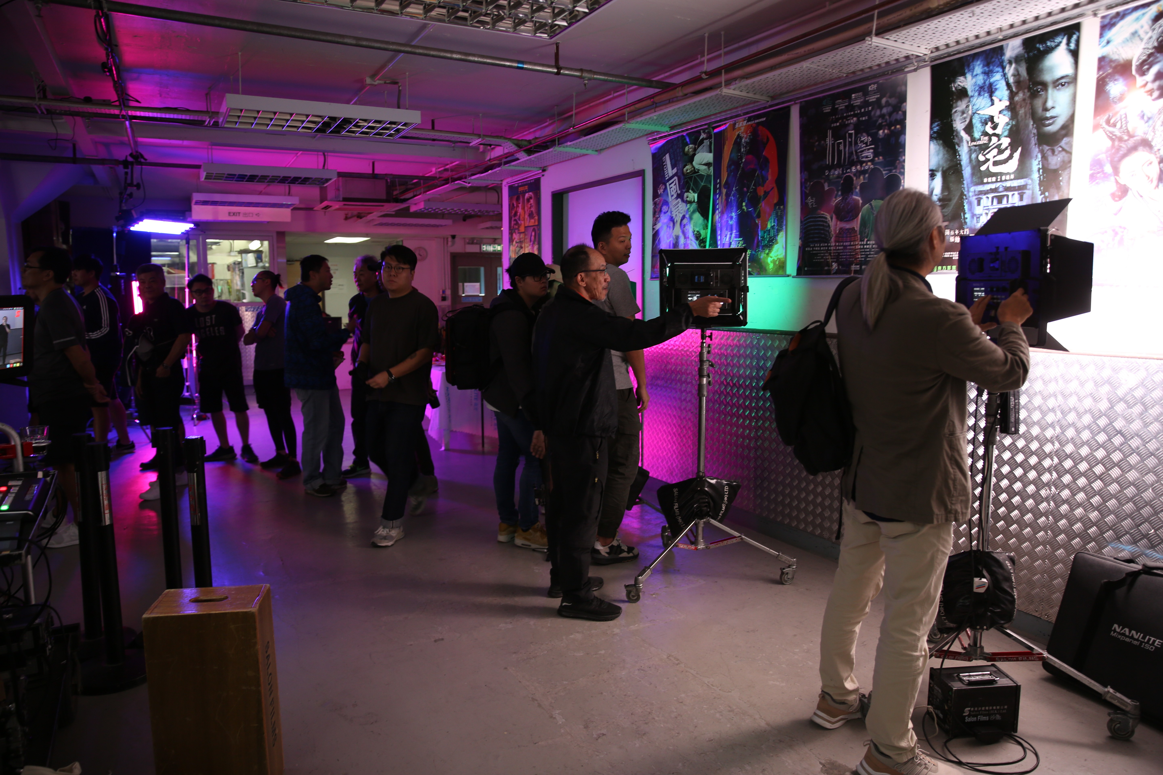

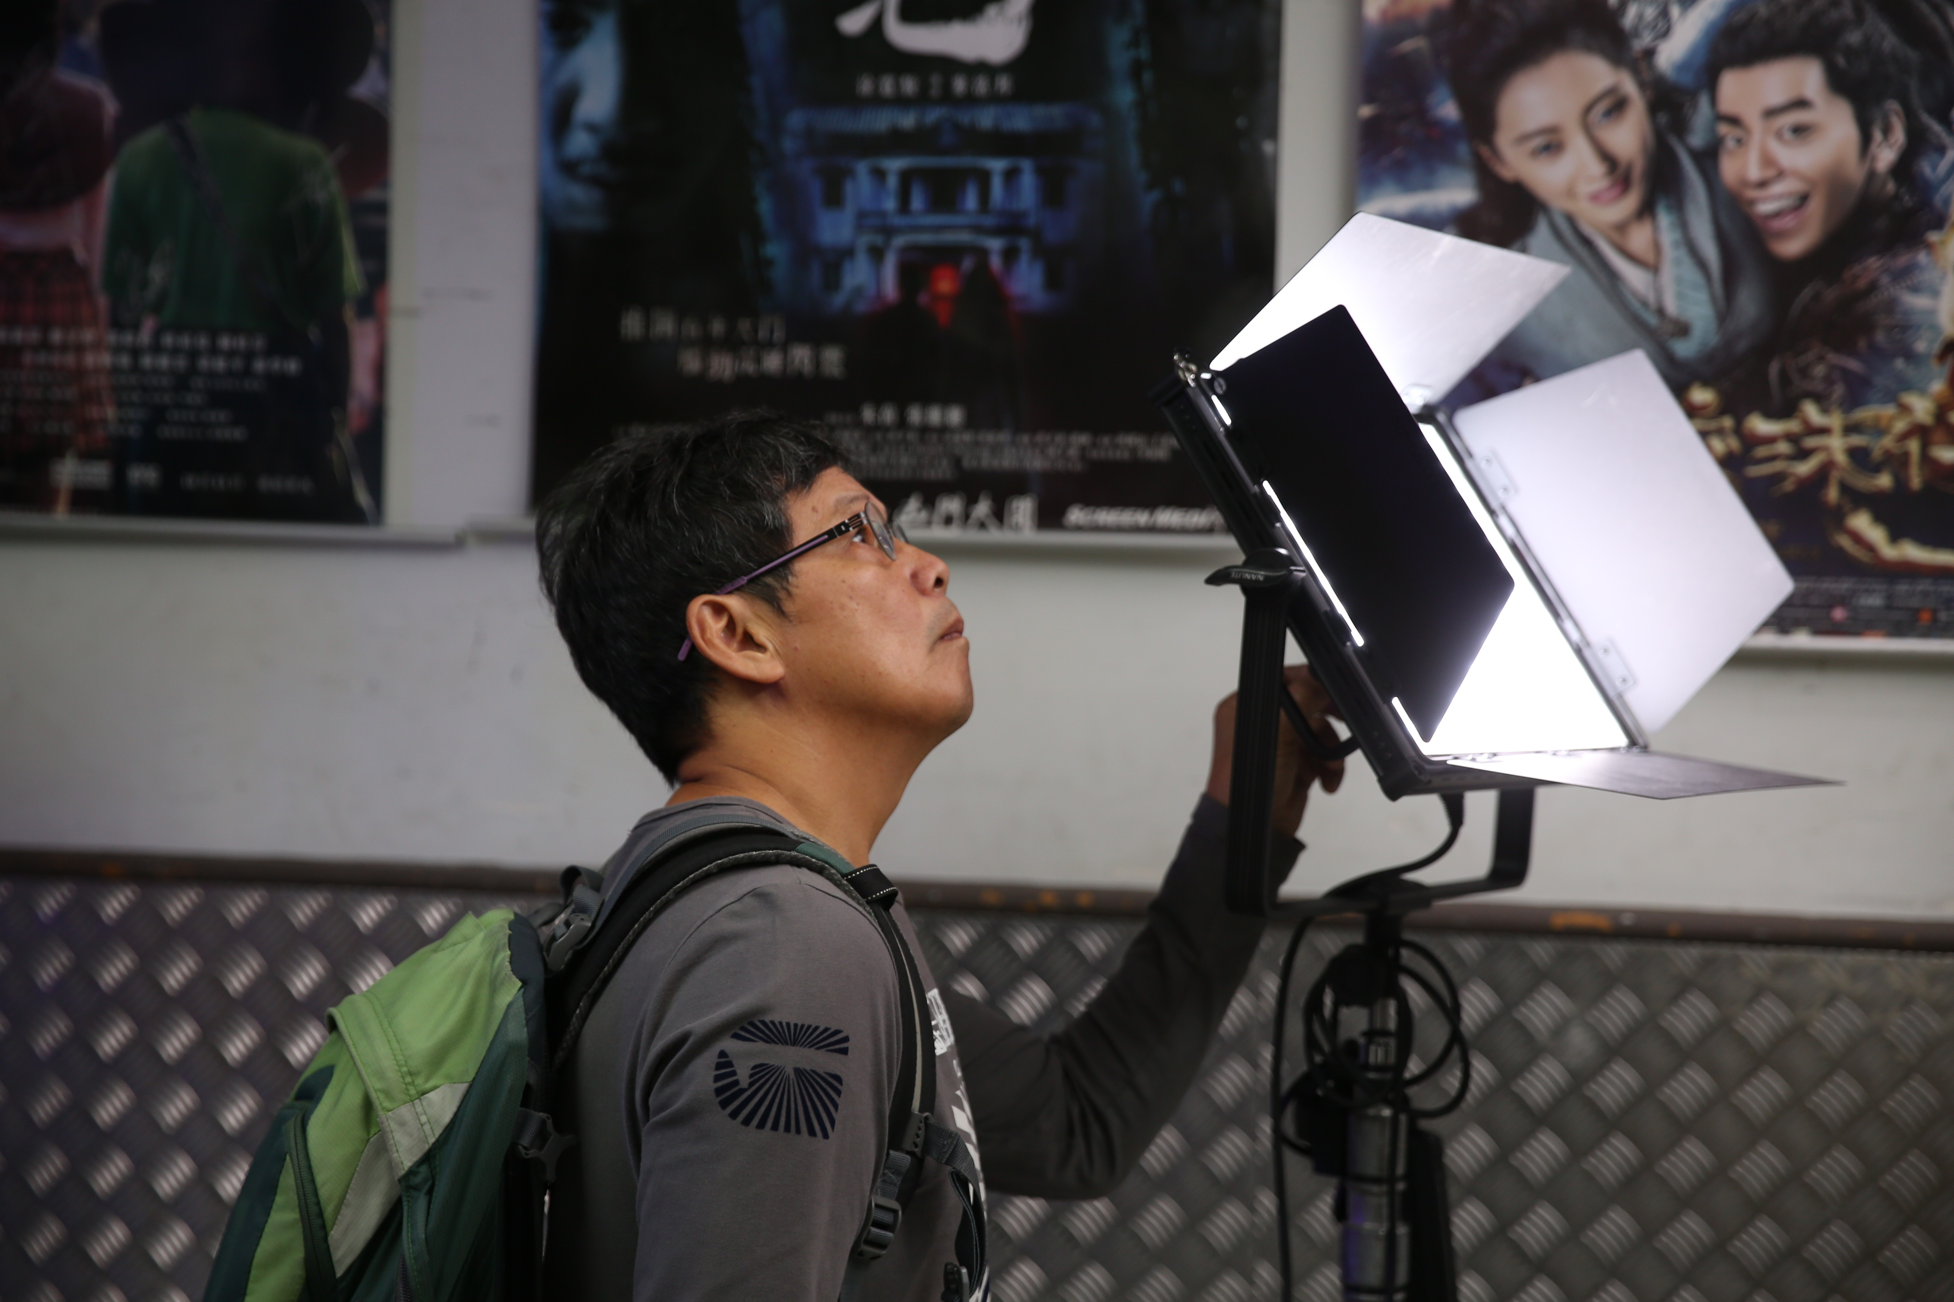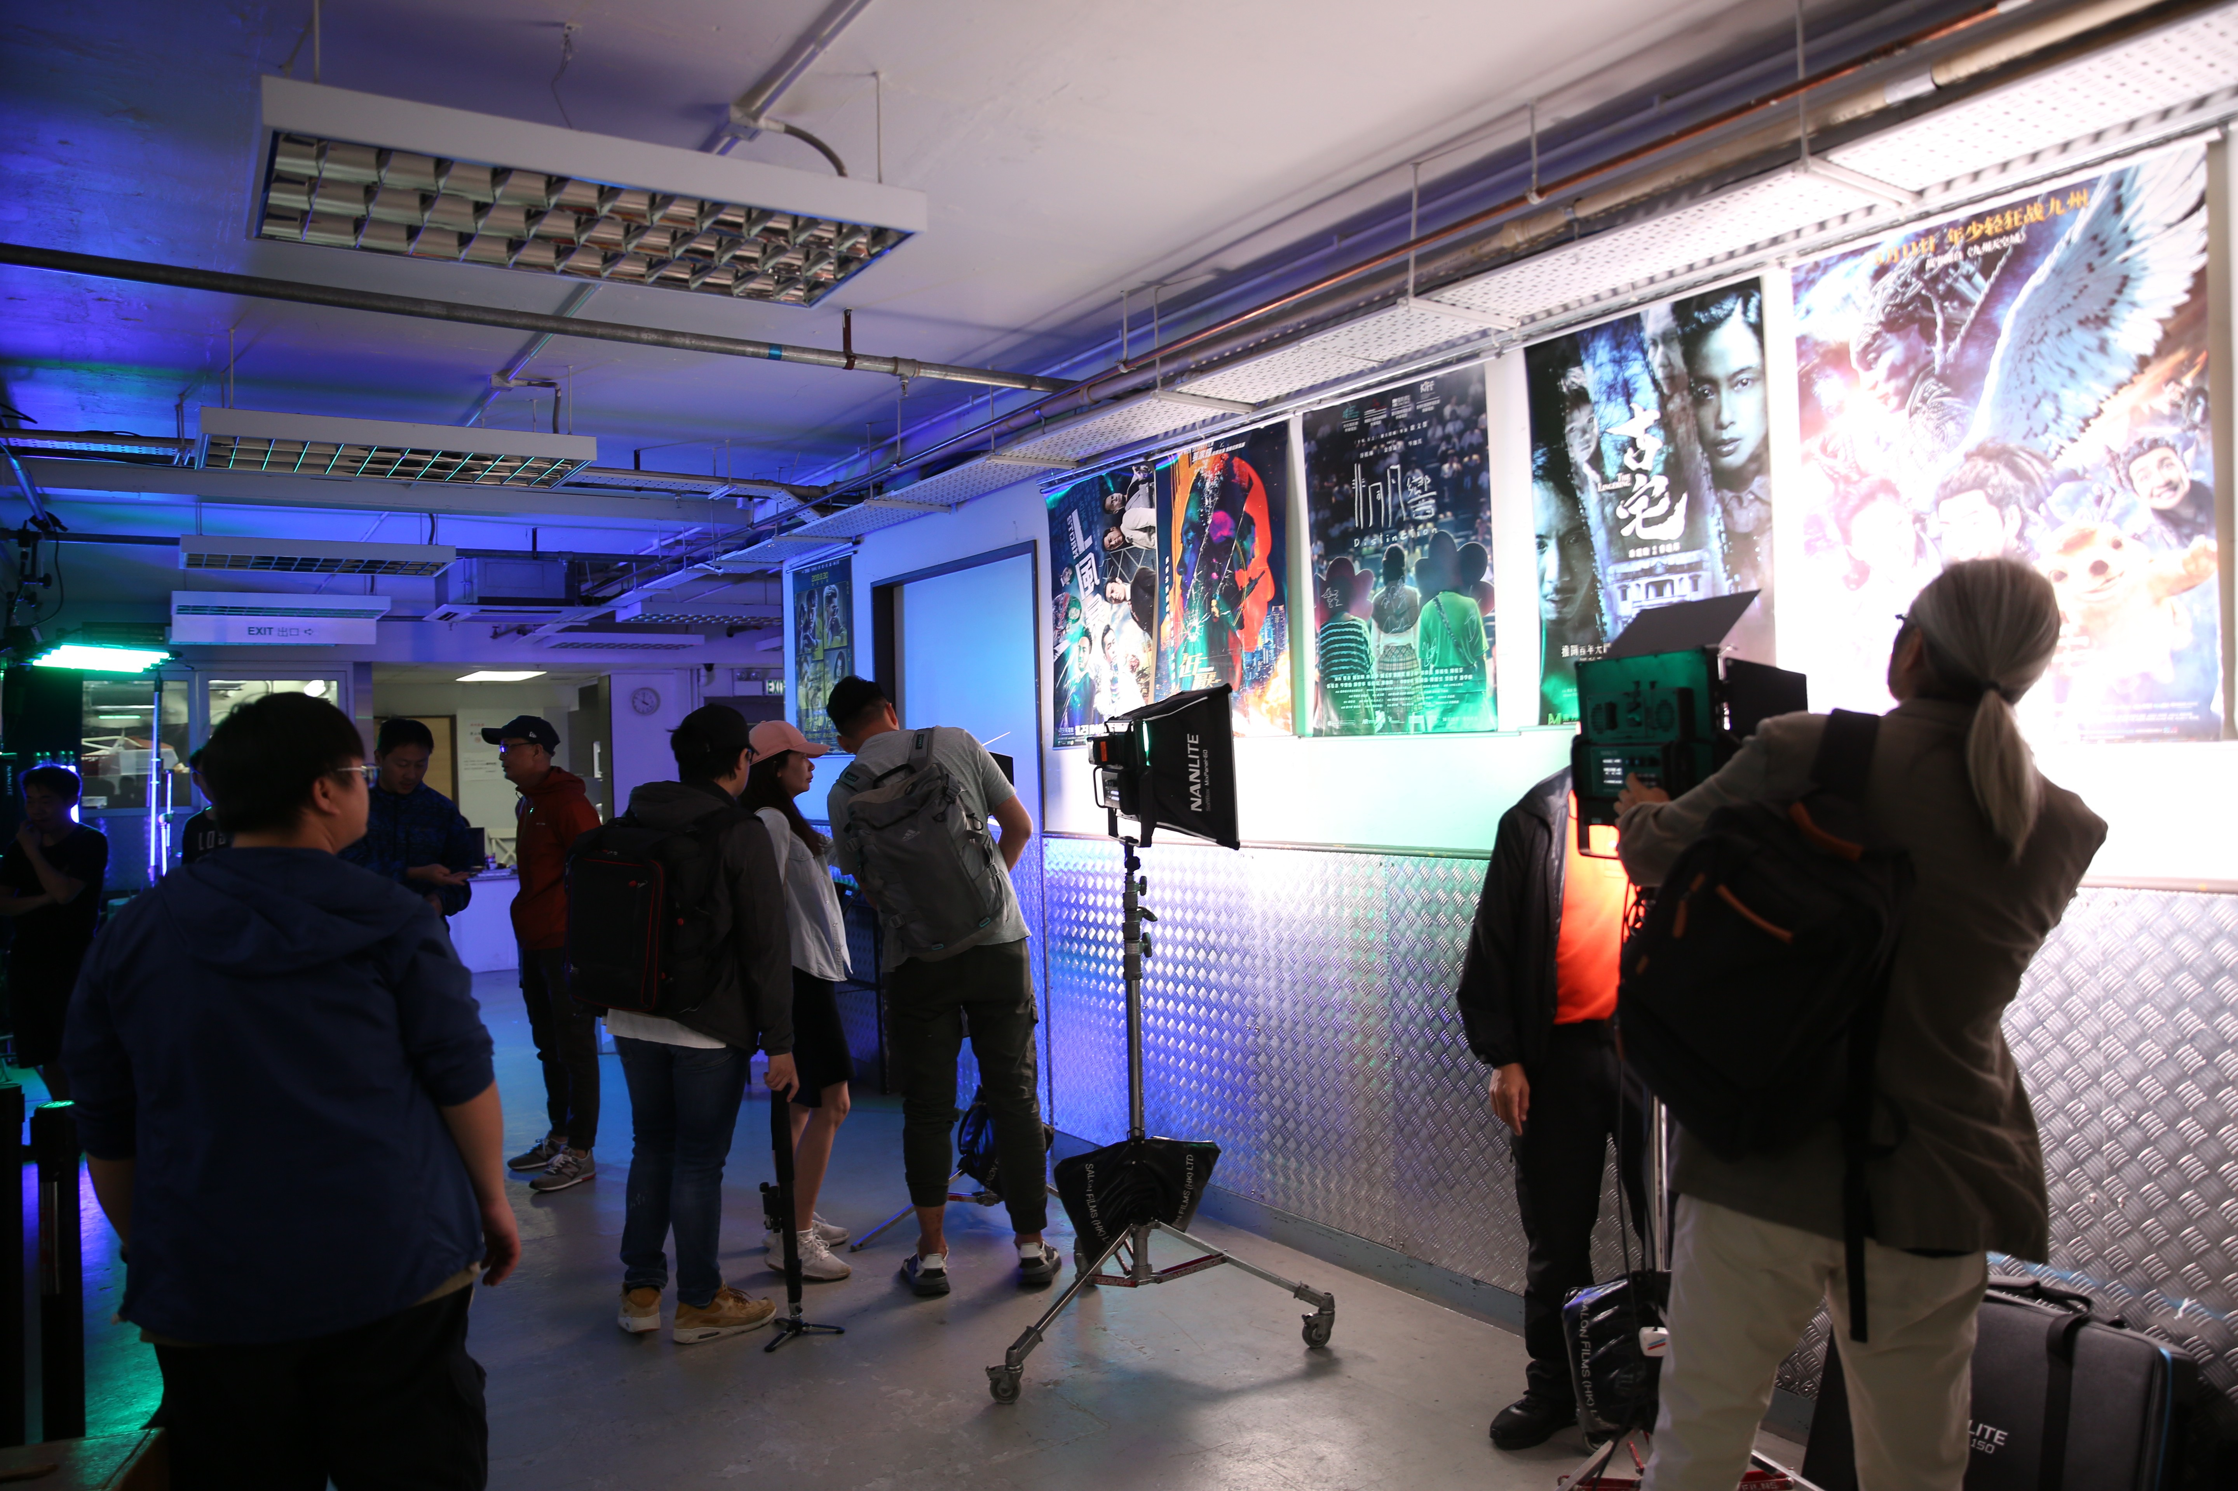

4

